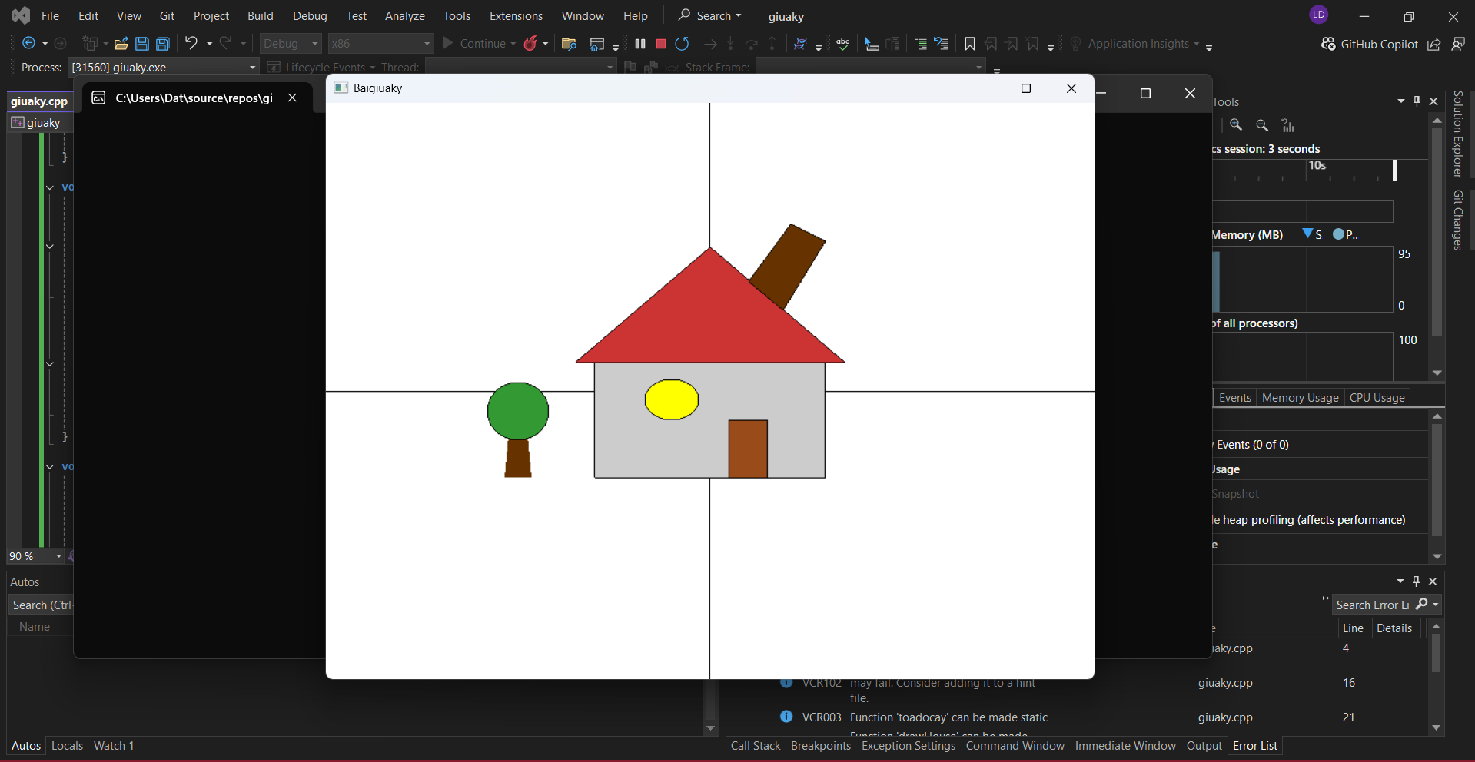
Ảnh sản phẩm
Code sản phẩm:
#include <GL/glut.h>
#include <cmath>

void vetrucxy() {
glColor3f(0.0f, 0.0f, 0.0f);
glLineWidth(1.0f);

glBegin(GL_LINES);
glVertex2f(-1.0f, 0.0f);
glVertex2f(1.0f, 0.0f);
glEnd();

glBegin(GL_LINES);
glVertex2f(0.0f, -1.0f);
glVertex2f(0.0f, 1.0f);
glEnd();

glLineWidth(1.0f);
}

void toadocay(float x, float y) {
glColor3f(0.4f, 0.2f, 0.0f);
glBegin(GL_POLYGON);
glVertex2f(x - 0.035f, y);
glVertex2f(x + 0.035f, y);
glVertex2f(x + 0.0225f, y + 0.18f);
glVertex2f(x - 0.0225f, y + 0.18f);
glEnd();

glColor3f(0.2f, 0.6f, 0.2f);
glBegin(GL_POLYGON);
for (int i = 0; i < 360; i++) {
float angle = i * 3.14159f / 180.0f;
glVertex2f(x + 0.08f * cos(angle), y + 0.23f + 0.1f * sin(angle));
}
glEnd();
// Viền
glColor3f(0.0f, 0.0f, 0.0f);
glBegin(GL_LINE_LOOP);
for (int i = 0; i < 360; i++) {
float angle = i * 3.14159f / 180.0f;
glVertex2f(x + 0.08f * cos(angle), y + 0.23f + 0.1f * sin(angle));
}
glEnd();
}

void drawHouse() {

toadocay(-0.5f, -0.3f);

// Nhà
glColor3f(0.8f, 0.8f, 0.8f);
glBegin(GL_POLYGON);
glVertex2f(-0.3f, -0.3f);
glVertex2f(0.3f, -0.3f);
glVertex2f(0.3f, 0.1f);
glVertex2f(-0.3f, 0.1f);
glEnd();
// Viền đen
glColor3f(0.0f, 0.0f, 0.0f);
glBegin(GL_LINE_LOOP);
glVertex2f(-0.3f, -0.3f);
glVertex2f(0.3f, -0.3f);
glVertex2f(0.3f, 0.1f);
glVertex2f(-0.3f, 0.1f);
glEnd();

// Mái nhà
glColor3f(0.8f, 0.2f, 0.2f);
glBegin(GL_POLYGON);
glVertex2f(-0.35f, 0.1f);
glVertex2f(0.35f, 0.1f);
glVertex2f(0.0f, 0.5f);
glEnd();
// Viền đen
glColor3f(0.0f, 0.0f, 0.0f);
glBegin(GL_LINE_LOOP);
glVertex2f(-0.35f, 0.1f);
glVertex2f(0.35f, 0.1f);
glVertex2f(0.0f, 0.5f);
glEnd();

// Vẽ cửa
glColor3f(0.6f, 0.3f, 0.1f);
glBegin(GL_POLYGON);
glVertex2f(0.05f, -0.3f);
glVertex2f(0.15f, -0.3f);
glVertex2f(0.15f, -0.1f);
glVertex2f(0.05f, -0.1f);
glEnd();
// Viền đen
glColor3f(0.0f, 0.0f, 0.0f);
glBegin(GL_LINE_LOOP);
glVertex2f(0.05f, -0.3f);
glVertex2f(0.15f, -0.3f);
glVertex2f(0.15f, -0.1f);
glVertex2f(0.05f, -0.1f);
glEnd();

// Ống khói
glColor3f(0.4f, 0.2f, 0.0f);
glBegin(GL_POLYGON);
glVertex2f(0.19f, 0.28f);
glVertex2f(0.1f, 0.38f);
glVertex2f(0.21f, 0.58f);
glVertex2f(0.3f, 0.52f);
glEnd();
// Viền đen
glColor3f(0.0f, 0.0f, 0.0f);
glBegin(GL_LINE_LOOP);
glVertex2f(0.19f, 0.28f);
glVertex2f(0.1f, 0.38f);
glVertex2f(0.21f, 0.58f);
glVertex2f(0.3f, 0.52f);
glEnd();
}

void drawCuasotron(float centerX, float centerY, float radius) {
// Vẽ hình tròn - màu vàng
glColor3f(1.0f, 1.0f, 0.0f);
glBegin(GL_POLYGON);
for (int i = 0; i < 360; i++) {
float angle = i * 3.14159f / 180.0f;
glVertex2f(centerX + radius * cos(angle), centerY + radius * sin(angle));
}
glEnd();
// Viền đen
glColor3f(0.0f, 0.0f, 0.0f);
glBegin(GL_LINE_LOOP);
for (int i = 0; i < 360; i++) {
float angle = i * 3.14159f / 180.0f;
glVertex2f(centerX + radius * cos(angle), centerY + radius * sin(angle));
}
glEnd();
}

void display() {
glClear(GL_COLOR_BUFFER_BIT);
vetrucxy();
drawHouse();
drawCuasotron(-0.1f, -0.03f, 0.07f);
glFlush();
}

void init() {
glClearColor(1.0f, 1.0f, 1.0f, 1.0f);
glMatrixMode(GL_PROJECTION);
glLoadIdentity();
gluOrtho2D(-1.0, 1.0, -1.0, 1.0);
}

int main(int argc, char** argv) {
glutInit(&argc, argv);
glutInitDisplayMode(GLUT_SINGLE | GLUT_RGB);
glutInitWindowSize(800, 600);
glutCreateWindow("Baigiuaky");
init();
glutDisplayFunc(display);
glutMainLoop();
return 0;
}

